Microsoft Knowledge Base

The connection string begins with the URI
- LDAP://.

For the server name, you can use the name of a domain controller in that domain-- let's say "dc1.corp.domain.com". That gives us
- LDAP://dc1.corp.domain.com/

The next bit is the fully qualified path of the container object where the binding user is located. Let's say you're using the "Administrator" account and your domain's name is "corp.domain.com". The "Administrator" account is in a container named "Users" located one level below the root of the domain. Thus, the fully qualified DN of the "Users" container would be:
- CN=Users,DC=corp,DC=domain,DC=com.

If the user you're binding with is in an OU, instead of a container, the path would include "OU=ou-name". So, using an account in an OU named Service Accounts that's a sub-OU of an OU named Corp Objects that's a sub-OU of a domain named corp.domain.com would have a fully-qualified path of
- OU=Service Accounts,OU=Corp Objects,DC=corp,DC=domain,DC=com.

Combine the LDAP://dc1.corp.domain.com/ with the fully qualified path to the container where the binding user is located and you've got your "connection string".

- LDAP://dc1.corp.domain.com/OU=Service Accounts,OU=Corp Objects,DC=corp,DC=domain,DC=com

GetLDAP Utility
GetLDAP utility is a simple console application utility that can be used to retrieve the correct LDAP connection string.

Usage:
1. Start a windows command shell using cmd.exe
2. browse the directories to the folder where the GetLDAP utility is stored
3. Launch the utility typing the utility name followed by valid login credentials (username, password and authentication domain) for a user available on the LDAP directory.

- GetLDAP.exe <user> <pwd> <domain>
- Example: GetLDAP.exe john.doe mysecretpwd thedomain

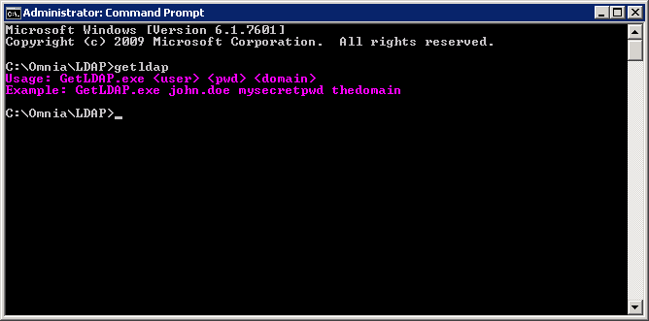
If the login credentials are valid, the utility returns the LDAP connection string to be used in OMNIA.
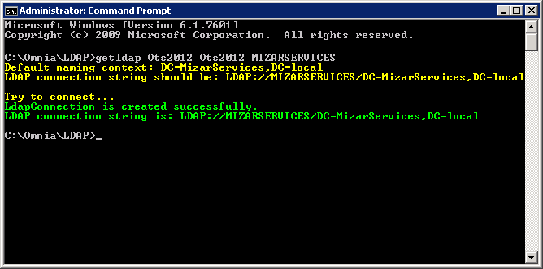
If the login credentials are not valid, the utility returns a connection error.
